Carlson Elementary
Two Choices, One School…

Thank you for your interest in Carlson Elementary, named after John and Carol Carlson, former educators in the Chandler Unified School District. We are a unique school that offers our families two different learning experiences within one school. Families have a choice between our “Classic” programming as well as our CTA “Traditional” programming. At Carlson, our mission is to prepare students to be future ready, civically engaged and capable of global citizenship by providing authentic and rigorous instruction in a safe, student-centered environment.

As a foundation of both programs, the Carlson staff is committed to providing a solid foundation of fundamental and higher-level thinking skills through a structured and rigorous curriculum that is consistent within each grade level and sequential throughout the grades within each program. Kindergarten through sixth grade curriculum and Arizona State Standards are taught using direct instructions, small group instruction, and research-based teaching strategies. Our teaching staff strives to make learning fun and relevant to each student.

At Carlson, we believe that it is our responsibility to provide the support necessary for all students to be successful not only academically but also socially and emotionally. We offer a wide variety of extracurricular opportunities for our students, after school clubs, fun-filled family events, community involvement, and a strong partnership with our parents and PTO.
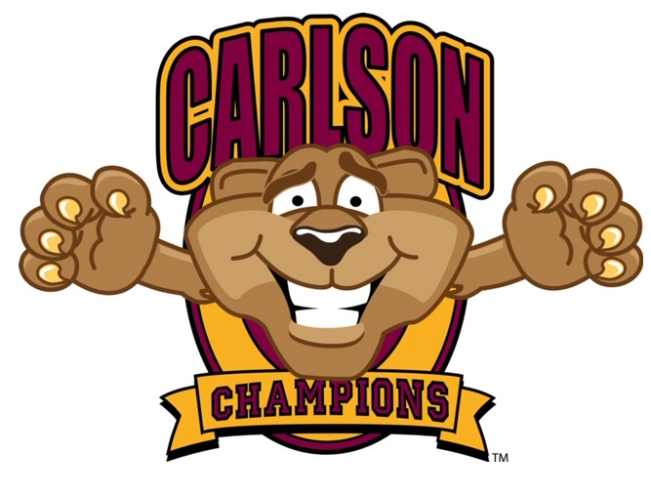
If you have any questions, please feel free to contact our office at 480-224-3800.
Sincerely,
Sarah Elliott
Sarah Elliott
Principal, Carlson Elementary
Home of the Champions

